**Borris Mixed N.S. Active School**

**Healthy Hallowe’en Treats**

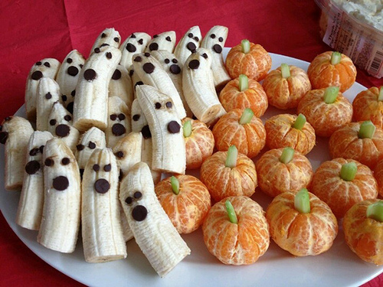 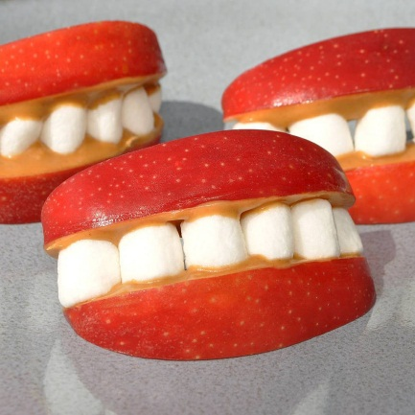 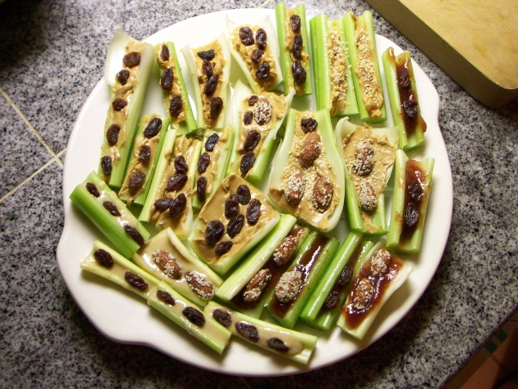

**Spiders On A Log**

Celery slices filled with peanut butter, and raisins to decorate.

**Boonanas**

Banana halves with choc chips to decorate!

**Tasty Apple Smiles!**

Apple slices spread with peanut butter and decorated with yogurt raisins/peanuts!

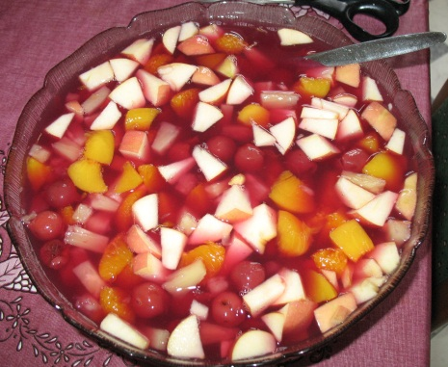 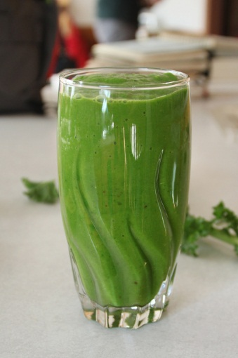 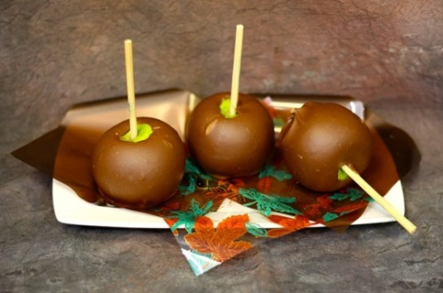

**Spooky Smoothies!**

Ask an adult to help you blend your favourite fruits in a blender! Choose your colours carefully to decide how spooky your smoothie turns out ☺

**Crunchy apples!**

**Ask an adult** to melt chocolate in a bowl. Dip your apple in, and then quickly roll it in some chopped nuts/seeds for an extra healthy crunch!

**Hallowe’en Punch**!

Ask an adult to help you chop up fruit into pieces. In a bowl, add some fruit juice and you have a healthy fruit punch ready to drink!