Hallowe’en Games To Get Us Moving!

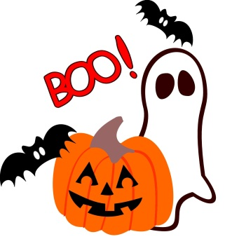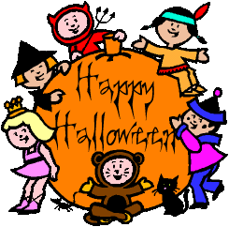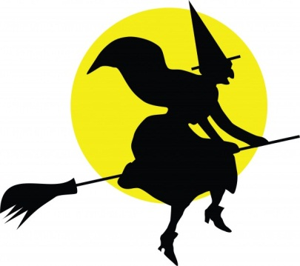

- Bean Bag Toss
Design a large cardboard box with 3 pumpkin-shaped faces. With an adult’s help, cut out each of the mouths to make 3 holes of different sizes (small, medium and large). Mark a line on the ground where you will start throwing from and take your turn to toss 3 bean bags. You score 15 points for getting it inside the smallest hole, 10 for the middle and 5 for the largest!

- Spooksical Statues
I’ve given this traditional game a twist! Try to find some spooky Hallowe’en music to boogie to. Then when the music stops, you must freeze and strike a scary monster pose! The scarier the better! The winner is the last one spooking

- Zombieland
This is a great one to play when friends are visiting. One person starts as the “Zombie”. The rest of the children (or adults!) lie still on the ground. The Zombie’s job is to make the others laugh or giggle, any way that they can! Once they have cracked a smile, they become a Zombie too and join the Zombie team! The winner is the last one keeping a straight face!

- Witch, Witch, Ghost
This is one for all ages! During this twist on the traditional “Duck, Duck, Goose” game, have fun chasing your friends and family while in your spooky costume! This is best played outside, or in a room with very little furniture.

- Mr. Monster Says…
Just like during “Simon Says”, you need to listen carefully to the instructions! You can use actions like “pumpkin fists”, “fly on a broom”, “walk like a zombie”, “crawl like a spider” and “fly like a ghost”. Get inventive and create some of your own poses too!

- Ghosts and Goblins
Another great game for a group of friends on a bright October day (fingers crossed!). Just like Rabbits and Rats, you all stand in a straight line, with the line leader facing the “Caller”. The caller explains that “Ghosts” means run to their left, and “Goblins” means run to their right. Listen carefully so you don’t come last…you never know who might catch you!

- Pass the Pumpkin
If you happen to have some pumpkins at home, you could try this twist on “pass the parcel”. Listening to some spooky tunes, the DJ pauses the music and the pumpkin holder wins a little prize!

- Pumpkin Races
As above, if you have pumpkins floating around, you could use them for this race. Split into teams and practise passing the pumpkins one to another overhead, under head or around your body. The team that gets the pumpkin from the beginning to the end in the quickest time is the winner.

- Monster Mash-up
Put on your favourite music and have a disco with your friends. Try and create dance moves that reflect your Hallowe’en character…zombie walks, flying witches, floating ghosts etc.

- Spook Spotter
To start the game, children form a circle. One child is chosen to be the Spook Spotter. The Spook Spotter leaves the room, while another child is chosen to be the Spook. The Spook selects subtle little movements to practise with the group, without leaving their places. Movements could include floating ghost movements, jerky movements like a zombie or a witch stirring a cauldron. Once the Spook has started the first action, the Spotter returns to the room and watches carefully. The Spotter has the task of guessing who is Spook in three guesses. Spook changes the action as often as possible without being seen and everyone copies. A new game begins after the three guesses and a new Spotter and a new Spook are chosen.

- Zombie Tag
Choose two (or more for large groups) Zombies who will be taggers. Zombies walk will their arms straight out in front of them, looking and sounding like a Zombie, and tag other players with a light touch. If someone is tagged, they also become a Zombie and begin tagging others. This is best played in an outside enclosed space, such as a garden. Once everyone is a Zombie, start again with two new taggers.

We hope you all have a fantastic Hallowe’en break. Stay safe!
Remember - keep active!!! 